Composite Solids with Repeated Components

Definition
# Source: AI Source: Provided by: [Data Path: Persons Table -> ID Column: 1, Name_En Column: Motasem Essam] -> From: [ChatGPT] on [7/25/2026]
Composite solids with repeated components are three-dimensional geometric objects formed by combining multiple copies of the same geometric solid or geometric component into a single structure.
The repeated components may have identical or different dimensions while maintaining the same geometric shape.
These components may be arranged in various configurations, such as linear, stacked, circular, symmetrical, or grid-based arrangements.
Examples include:
- A solid formed by stacking identical cubes.
- A rectangular structure made from multiple identical rectangular prisms.
- A cylinder formed by stacking several identical cylindrical sections.
- A solid made from repeated hemispheres.
- A structure consisting of multiple identical pyramids.
- A composite solid formed by arranging identical cylinders around a central axis.

Simple Definition
# Source: AI Source: Provided by: [Data Path: Persons Table -> ID Column: 1, Name_En Column: Motasem Essam] -> From: [ChatGPT] on [7/25/2026]
A composite solid with repeated components is a 3D shape created by joining multiple copies of the same geometric shape.
The repeated components may be arranged in different patterns to form a larger or more complex solid.

Geometric Representation
# Source: AI Source: Provided by: [Data Path: Persons Table -> ID Column: 1, Name_En Column: Motasem Essam] -> From: [ChatGPT] on [7/25/2026]
A composite solid with repeated components may consist of several geometric elements:
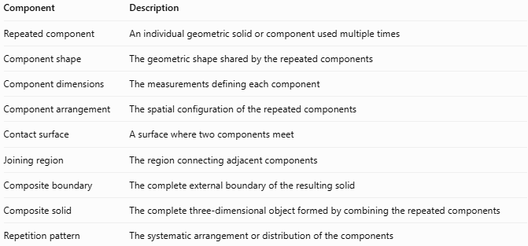
Component | Description
Repeated component | An individual geometric solid or component used multiple times
Component shape | The geometric shape shared by the repeated components
Component dimensions | The measurements defining each component
Component arrangement | The spatial configuration of the repeated components
Contact surface | A surface where two components meet
Joining region | The region connecting adjacent components
Composite boundary | The complete external boundary of the resulting solid
Composite solid | The complete three-dimensional object formed by combining the repeated components
Repetition pattern | The systematic arrangement or distribution of the components

Types of Composite Solids with Repeated Components
# Source: AI Source: Provided by: [Data Path: Persons Table -> ID Column: 1, Name_En Column: Motasem Essam] -> From: [ChatGPT] on [7/25/2026]
These solids can be classified according to the geometric shape of their repeated components.

Cube-Based Repeated Composite Solids
# Source: AI Source: Provided by: [Data Path: Persons Table -> ID Column: 1, Name_En Column: Motasem Essam] -> From: [ChatGPT] on [7/25/2026]
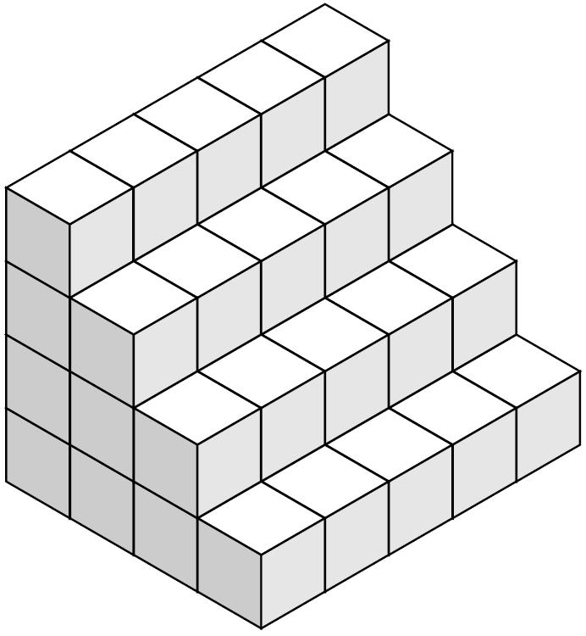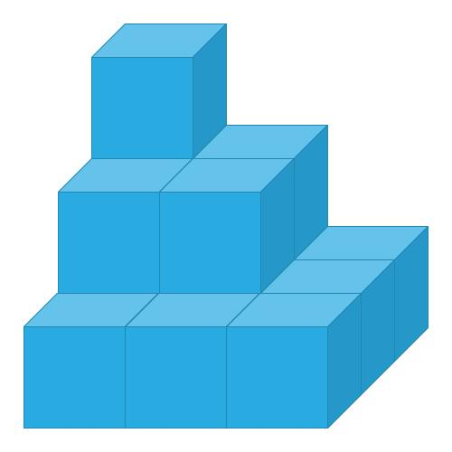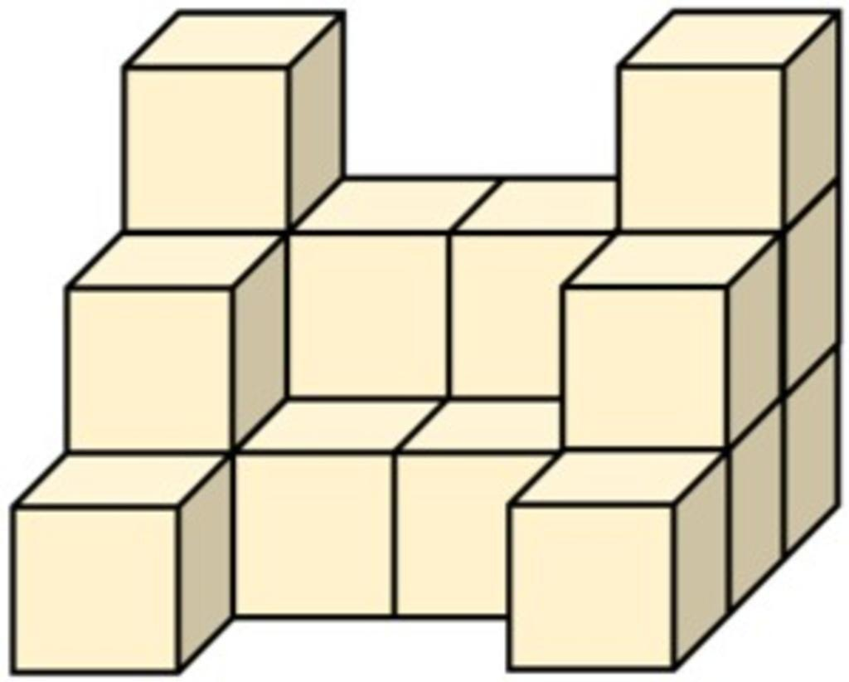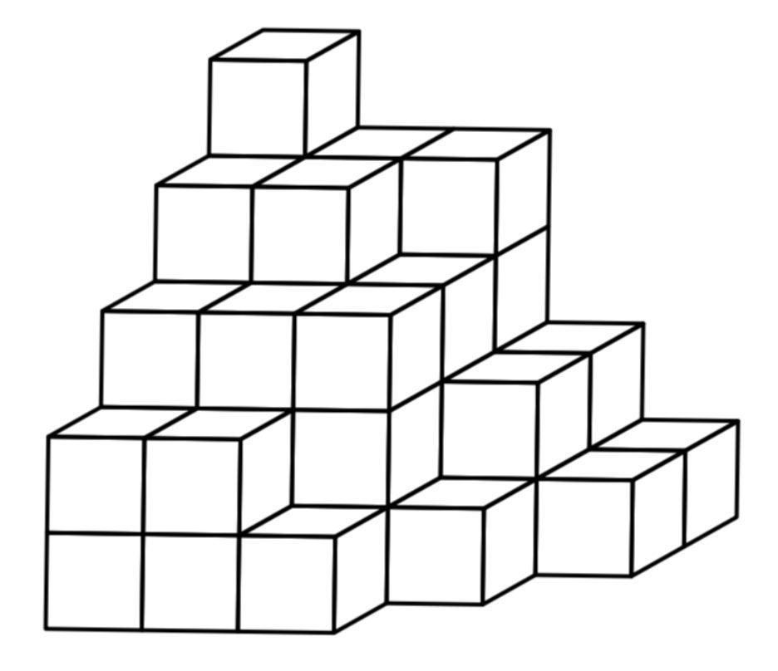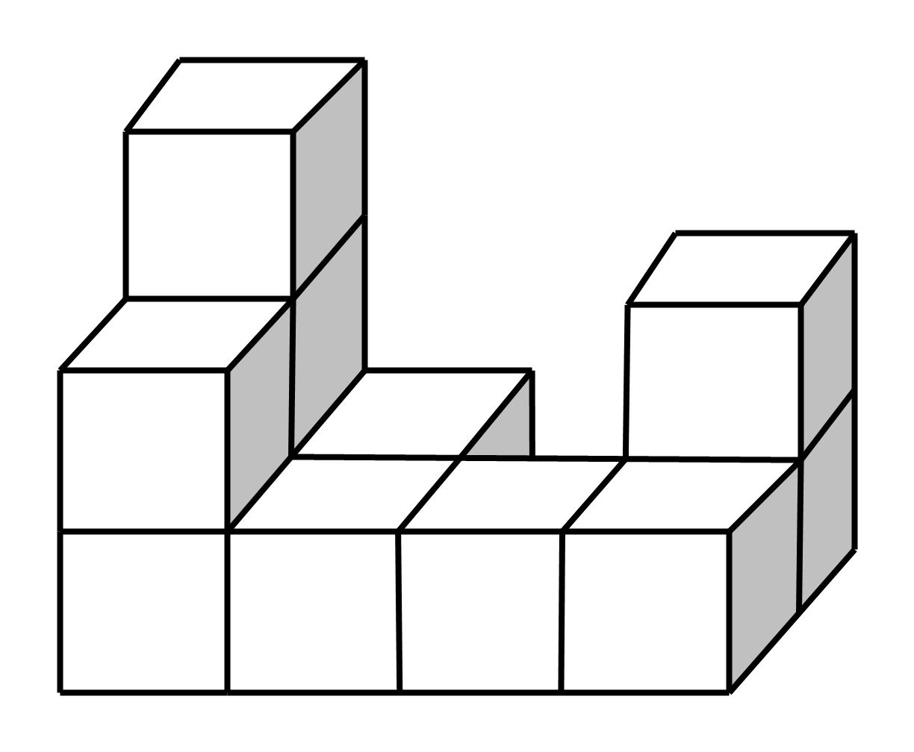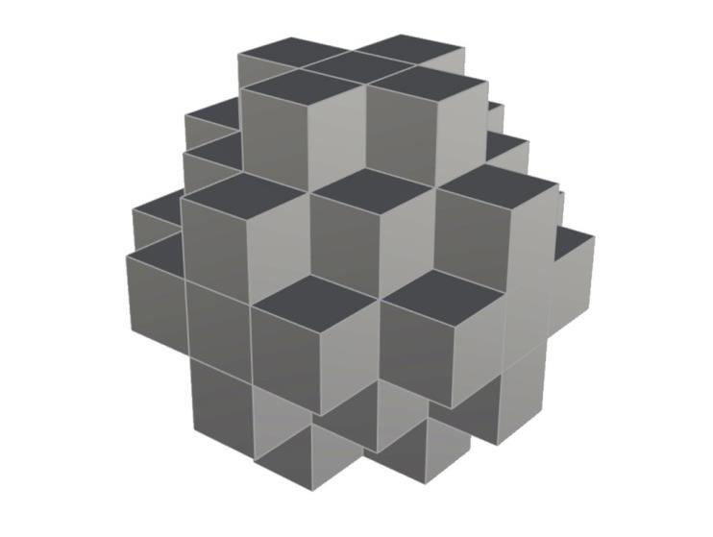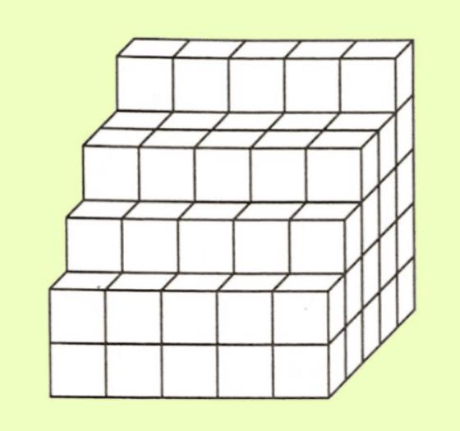
Created by joining multiple copies of identical or differently sized cubes.
Examples:
- Solid formed by stacking identical cubes vertically.
- Rectangular arrangement of identical cubes.
- Staircase-shaped solid made of identical cubes.
- Cross-shaped arrangement of cubes.
- Layered cubic structure.
- Symmetrical arrangement of cubes around a central cube.

Rectangular Prism-Based Repeated Composite Solids
# Source: AI Source: Provided by: [Data Path: Persons Table -> ID Column: 1, Name_En Column: Motasem Essam] -> From: [ChatGPT] on [7/25/2026]
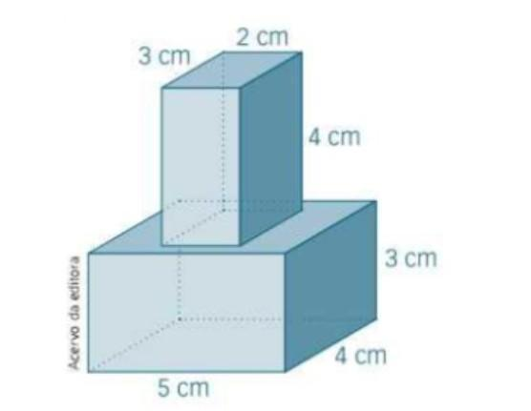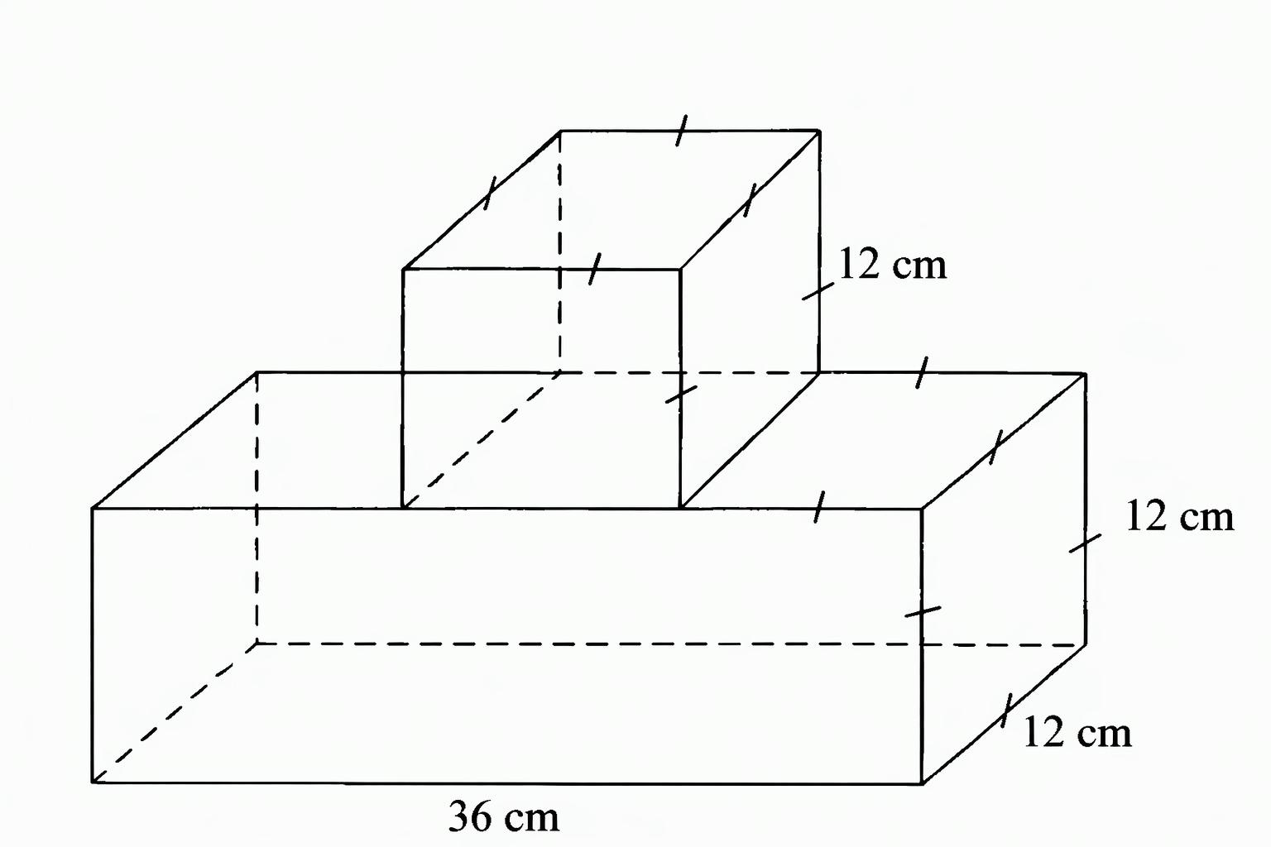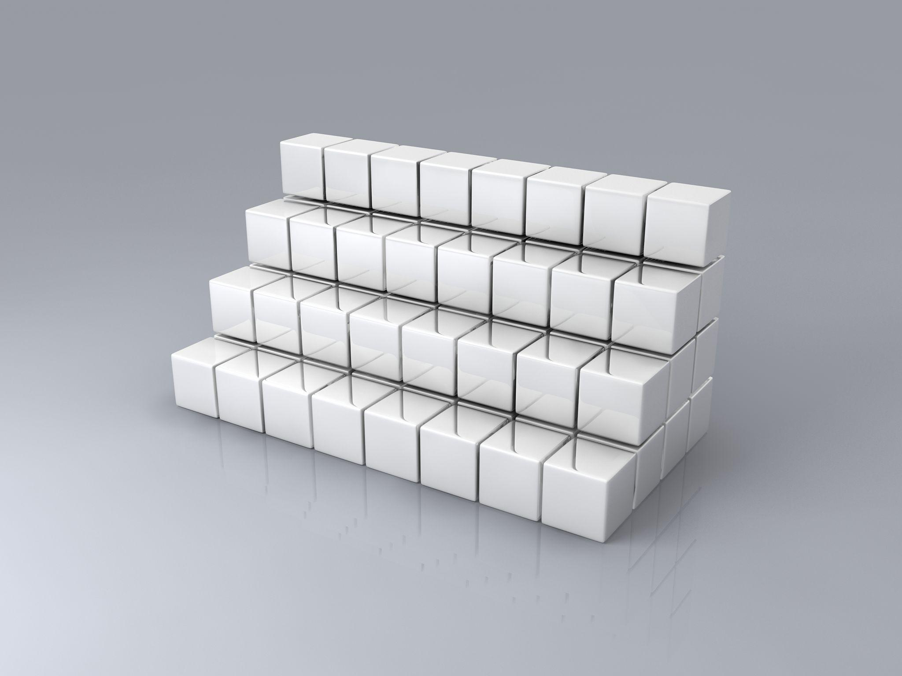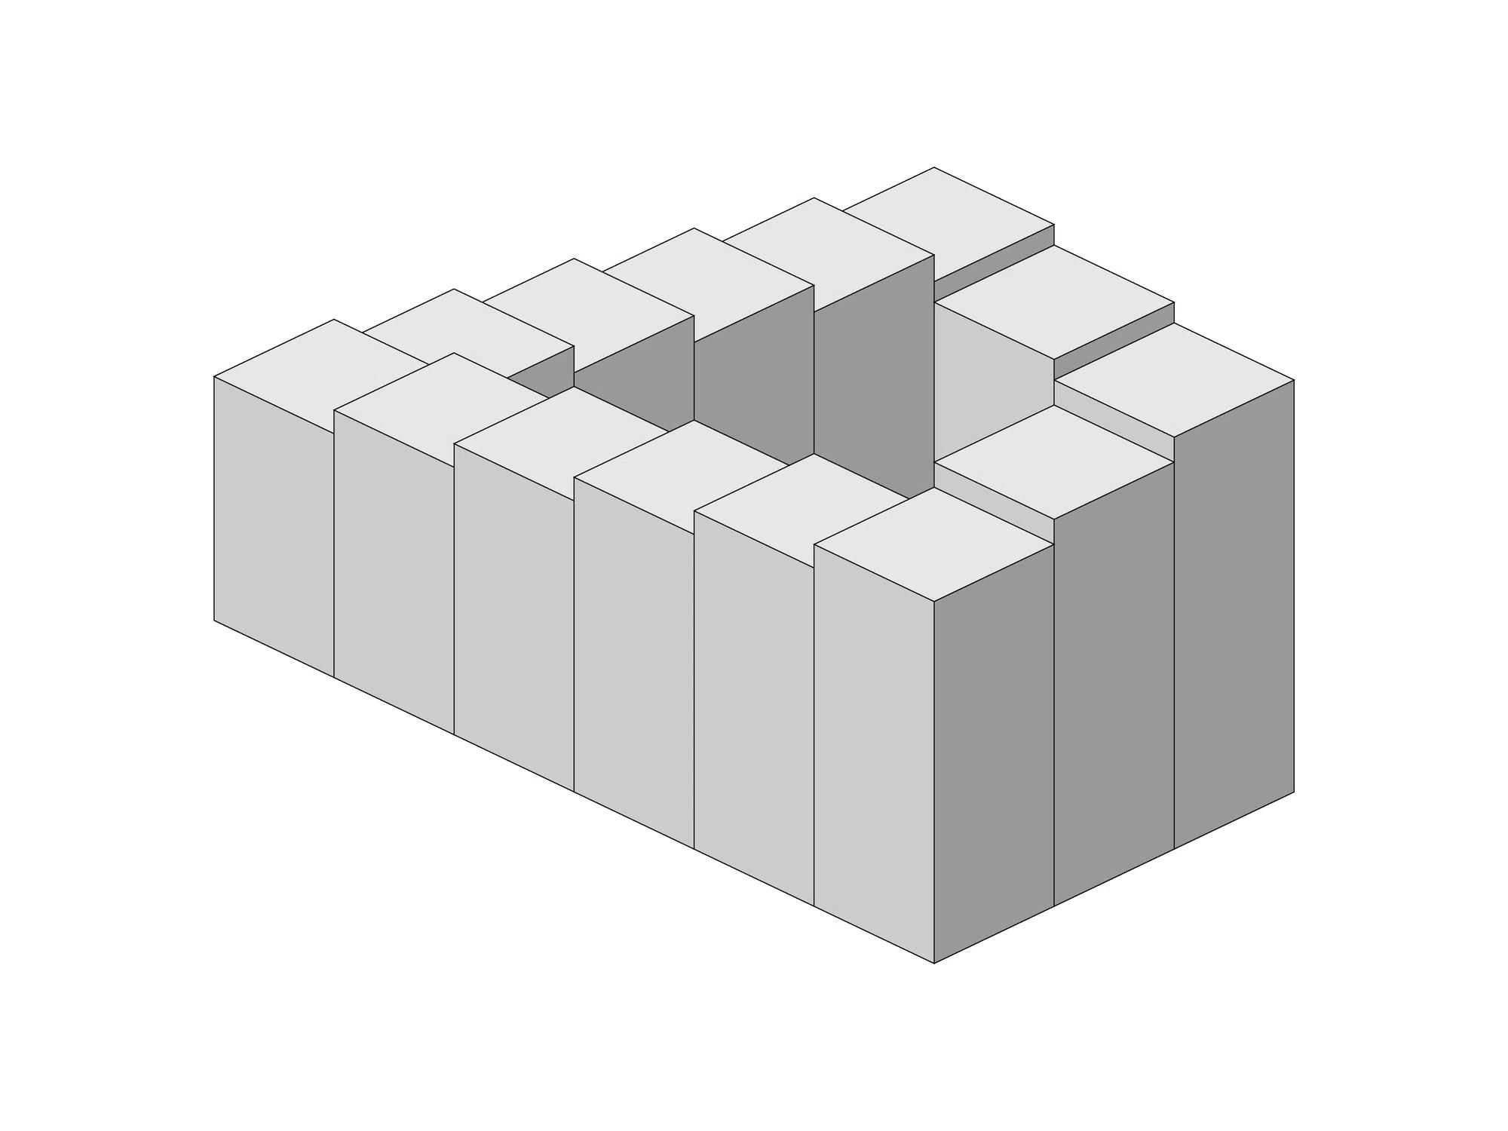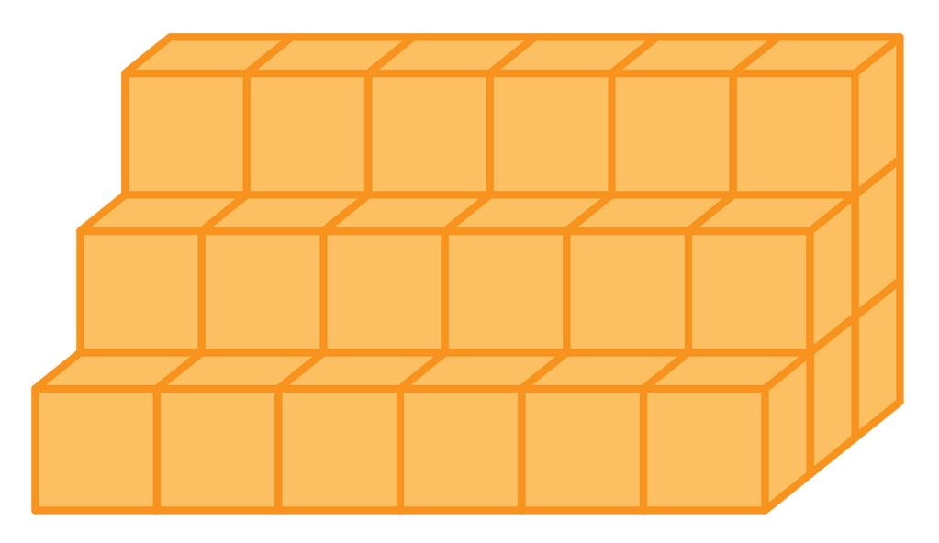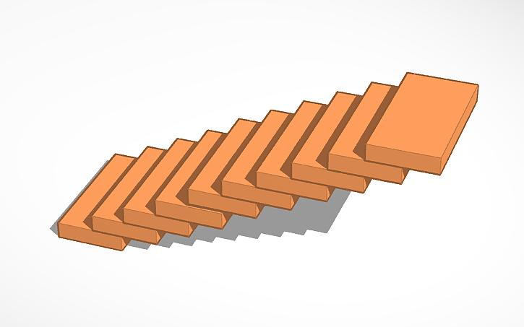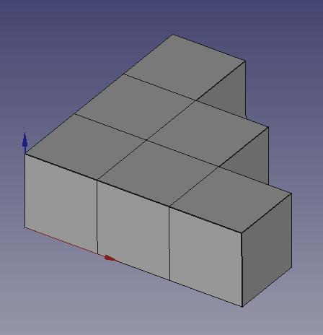
Created by joining multiple rectangular prisms with the same or different dimensions.
Examples:
- Solid formed by stacking identical rectangular prisms.
- Structure made of repeated rectangular blocks arranged in rows.
- Layered rectangular prism structure.
- Staircase-shaped solid made of rectangular prisms.
- Long composite block formed by joining identical rectangular prisms.

Cylinder-Based Repeated Composite Solids
# Source: AI Source: Provided by: [Data Path: Persons Table -> ID Column: 1, Name_En Column: Motasem Essam] -> From: [ChatGPT] on [7/25/2026]
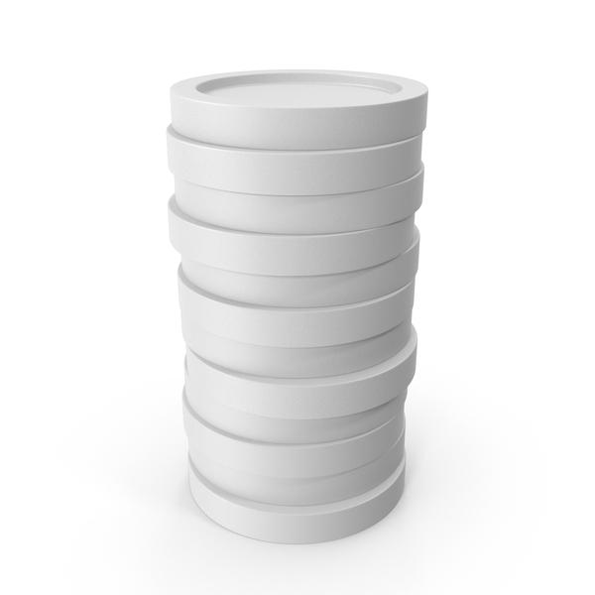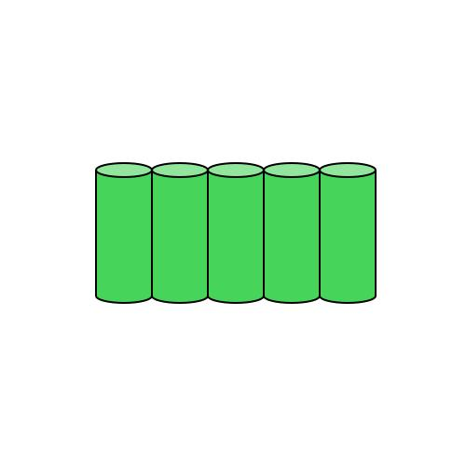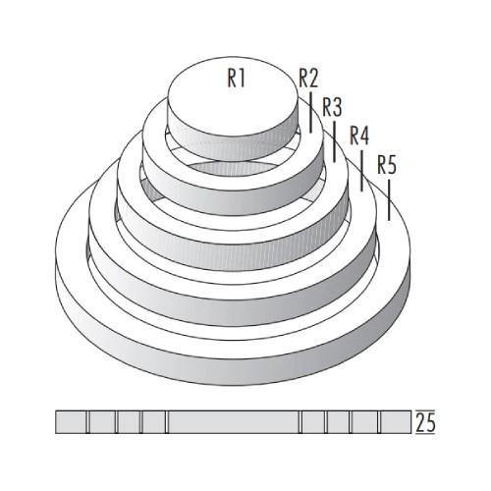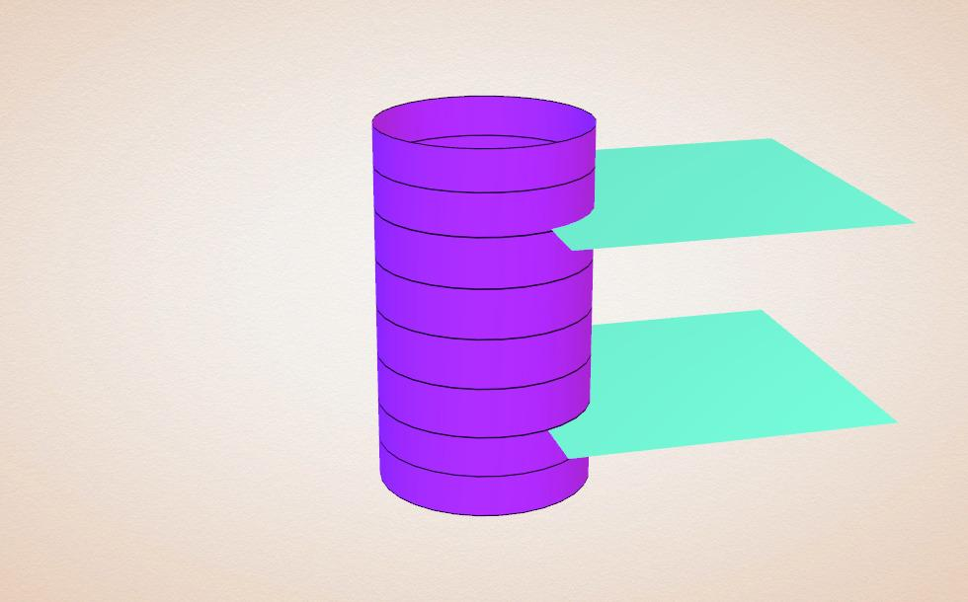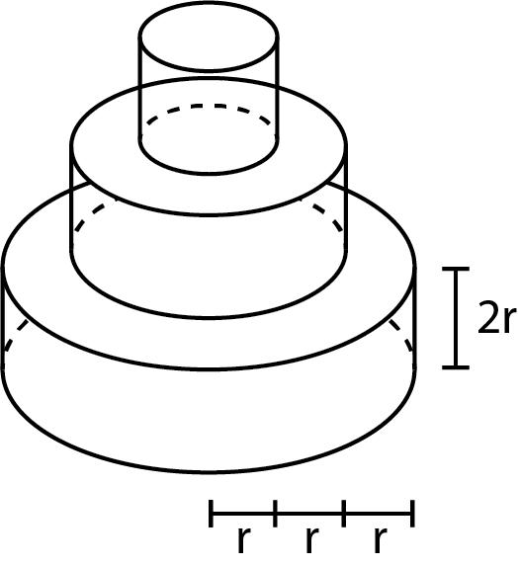
Created by joining multiple cylindrical components.
Examples:
- Solid formed by stacking identical cylinders.
- Structure made of cylinders arranged side by side.
- Composite cylindrical column formed from repeated cylindrical sections.
- Circular arrangement of identical cylinders around a central axis.
- Solid formed by joining identical cylinders end to end.

Cone-Based Repeated Composite Solids
# Source: AI Source: Provided by: [Data Path: Persons Table -> ID Column: 1, Name_En Column: Motasem Essam] -> From: [ChatGPT] on [7/25/2026]
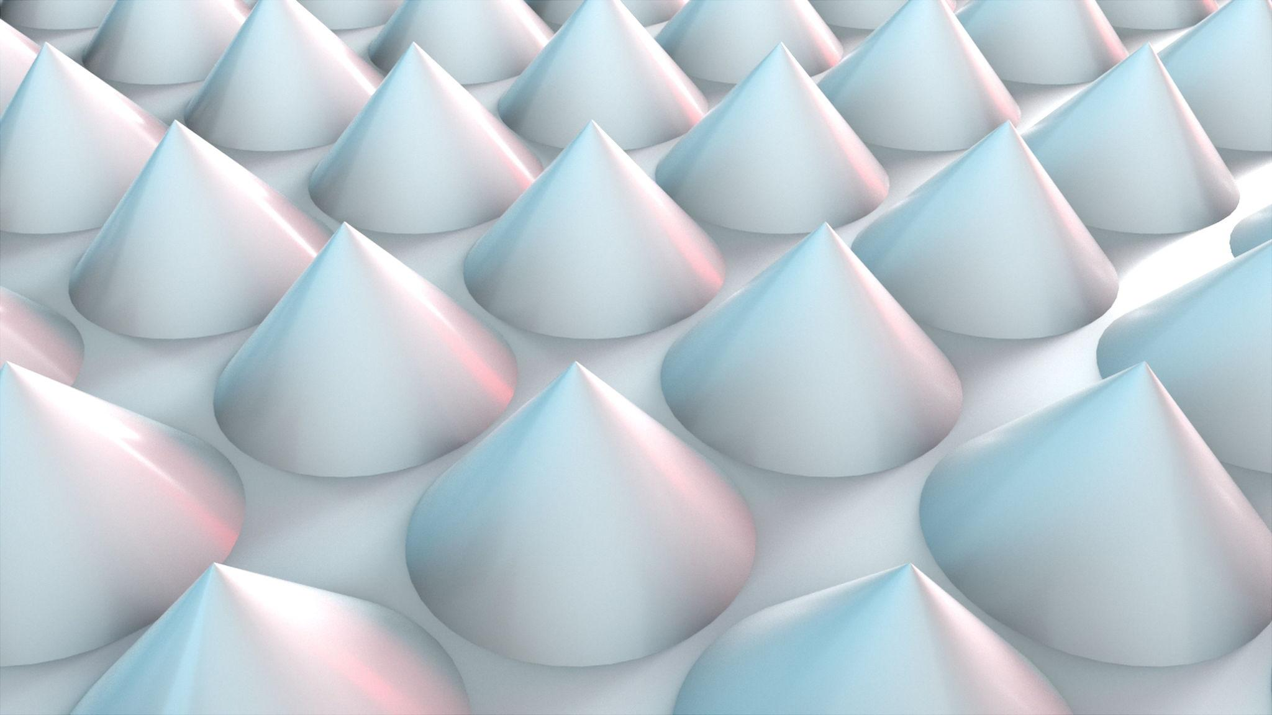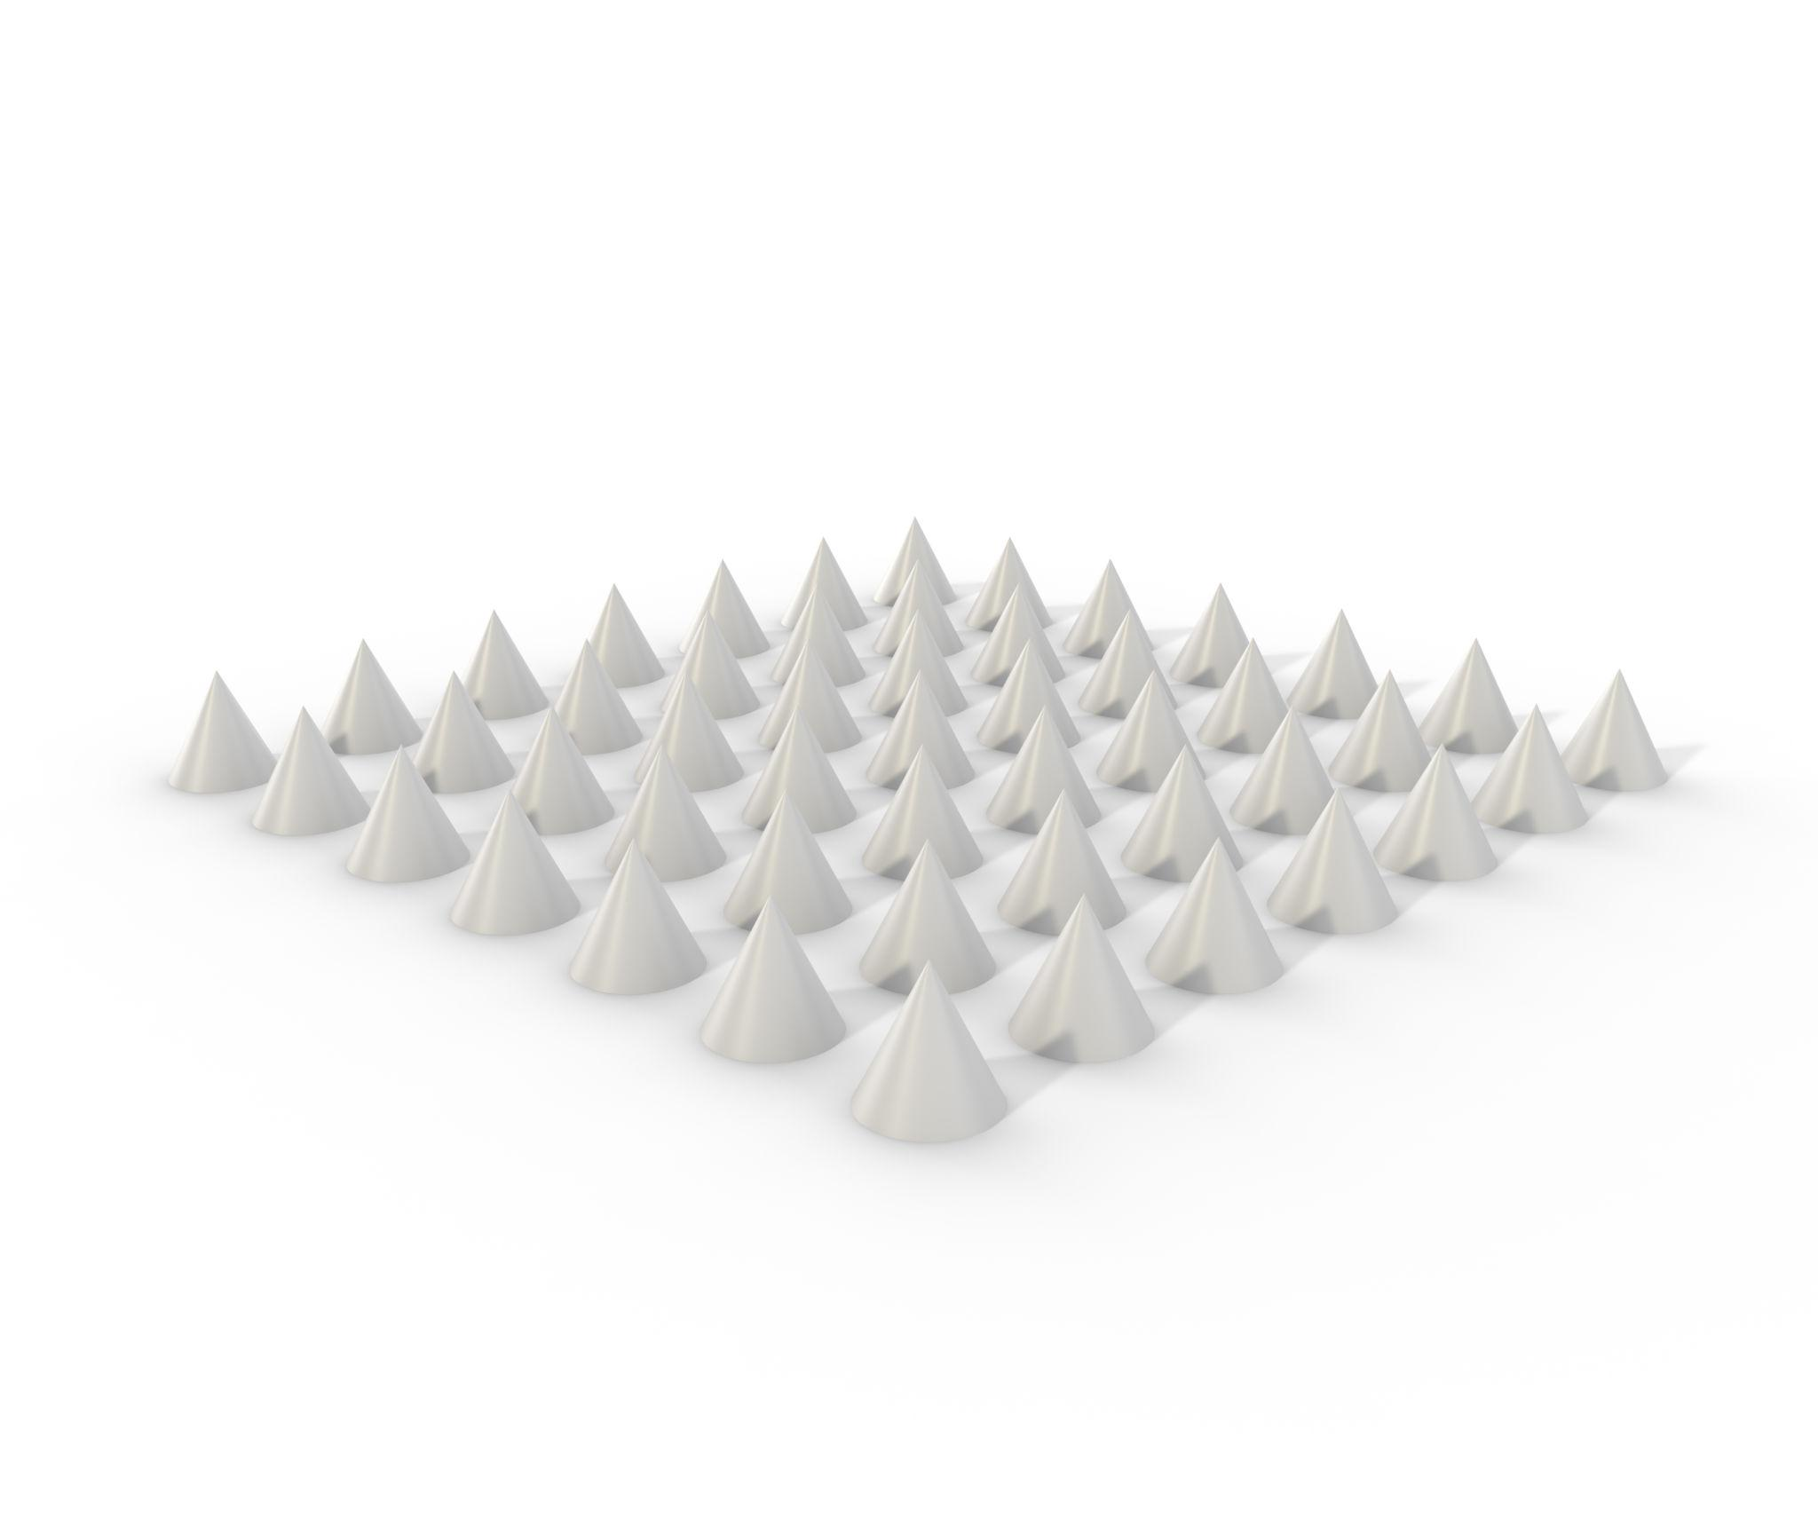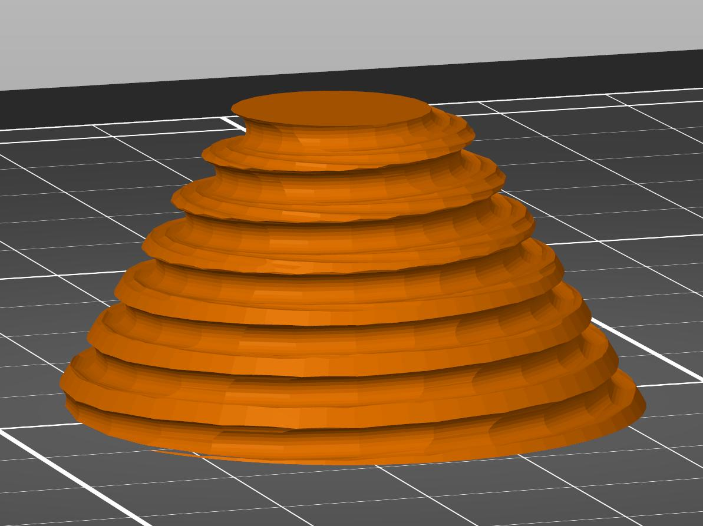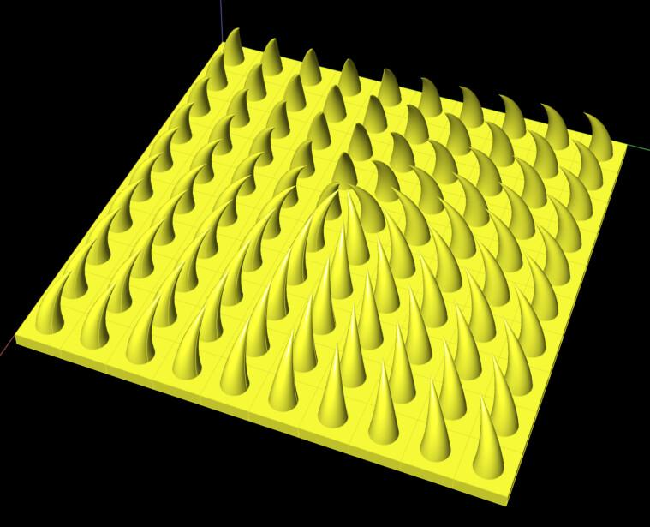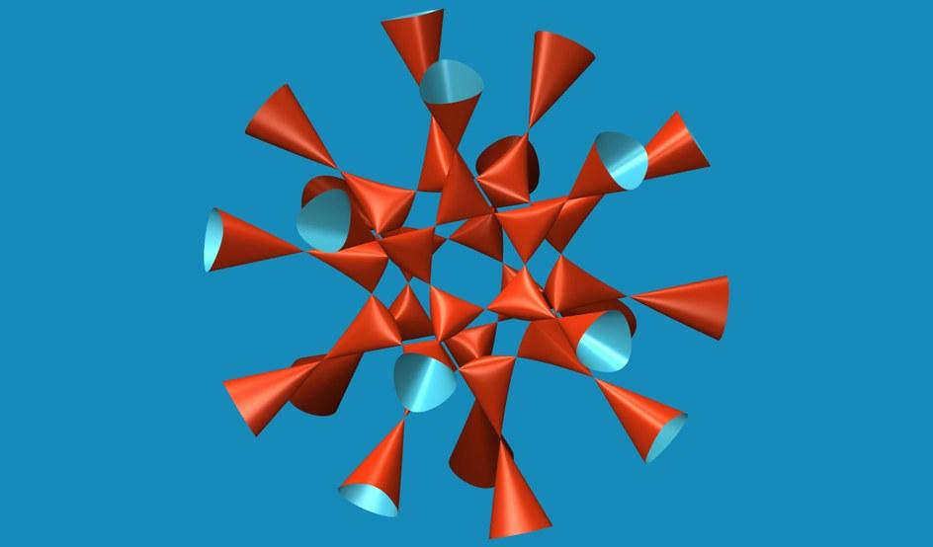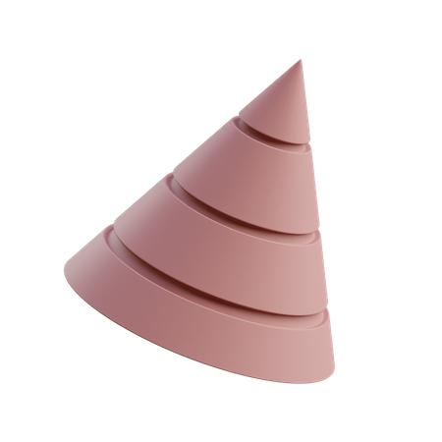
Created by combining multiple cone-shaped components.
Examples:
- Repeated cones arranged side by side.
- Structure formed by joining identical cones at their bases.
- Circular arrangement of cones around a central axis.
- Composite structure made of repeated conical sections.
- Solid formed by arranging identical cones in symmetrical positions.

Sphere-Based Repeated Composite Solids
# Source: AI Source: Provided by: [Data Path: Persons Table -> ID Column: 1, Name_En Column: Motasem Essam] -> From: [ChatGPT] on [7/25/2026]
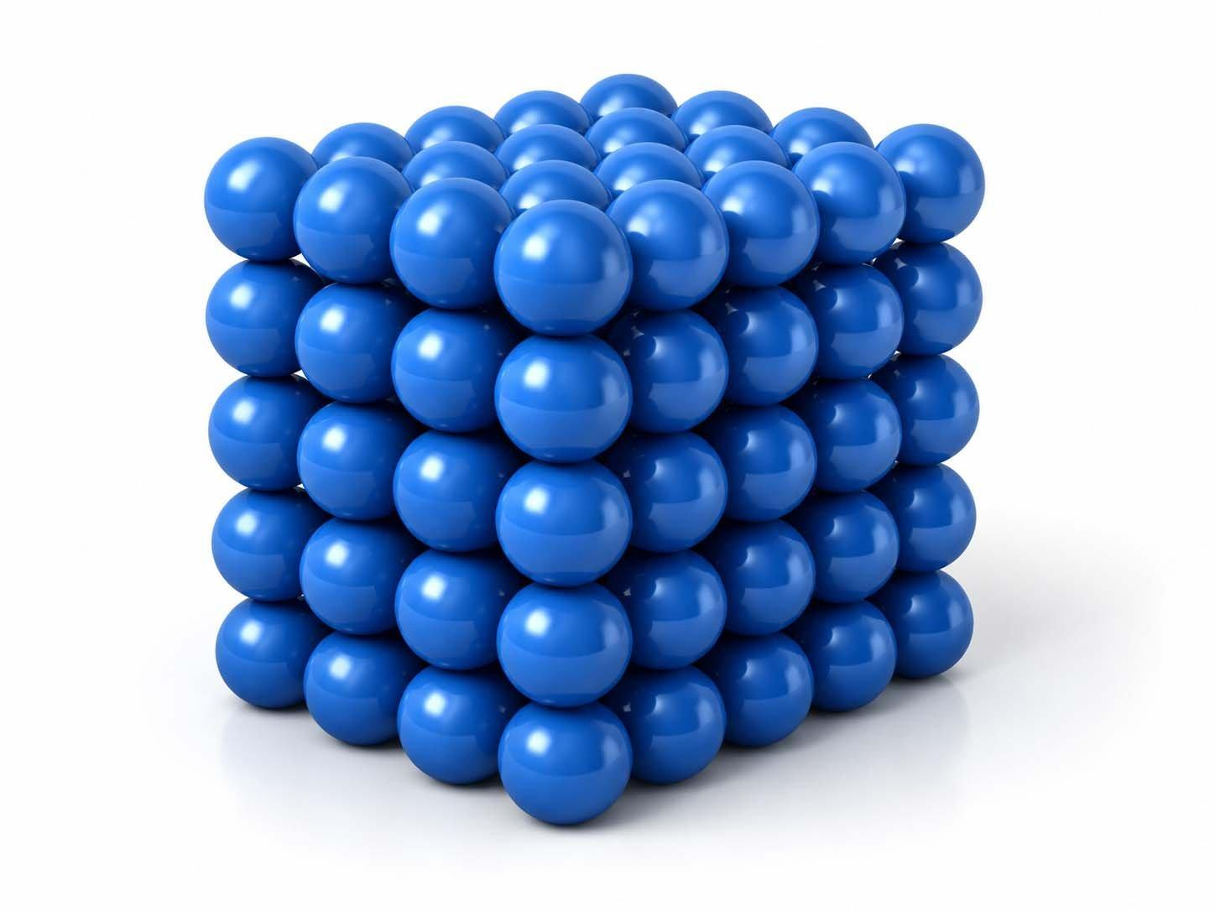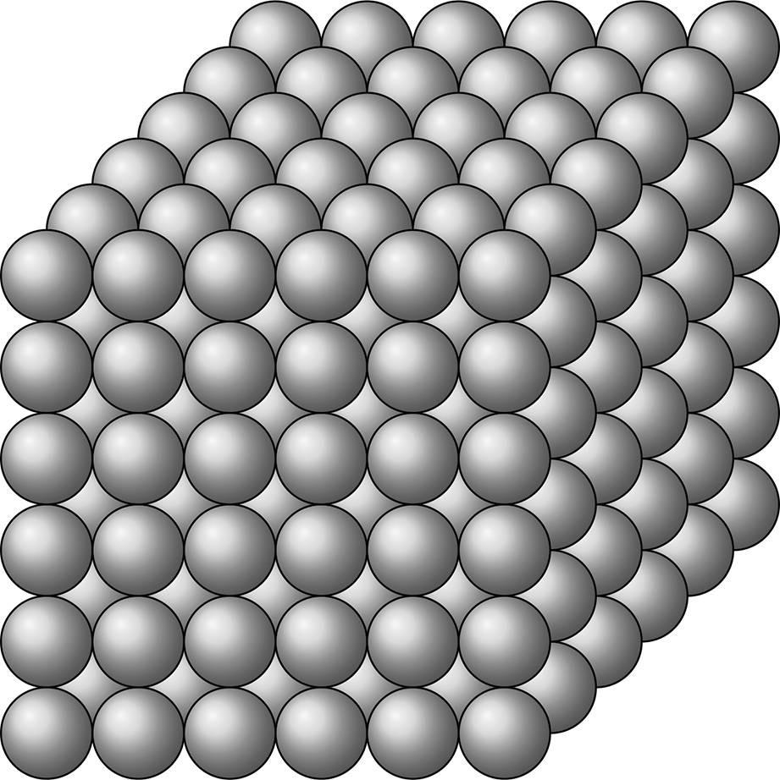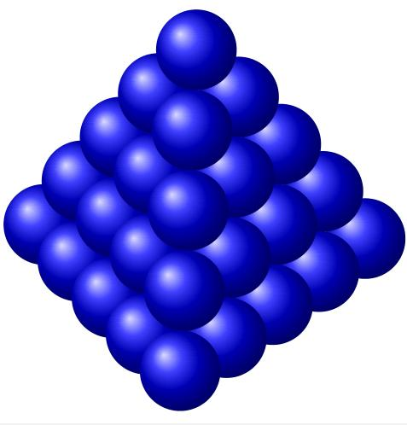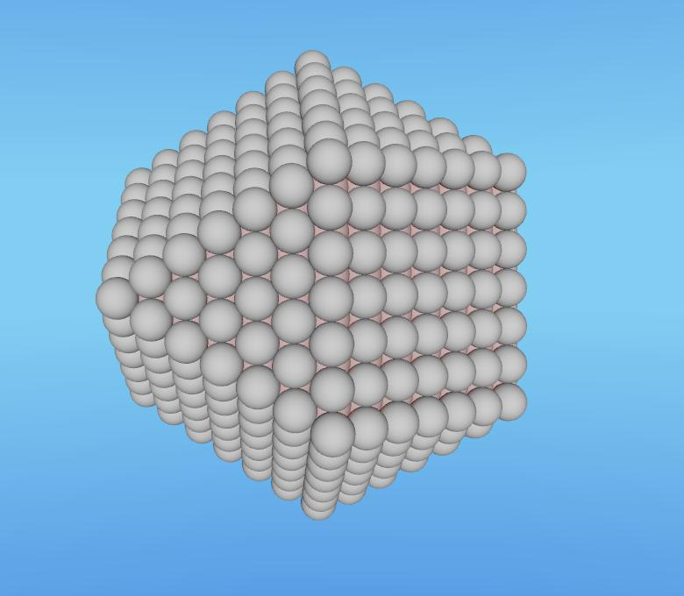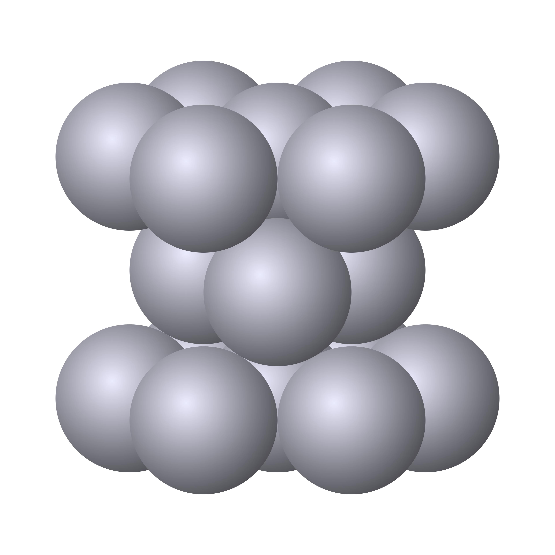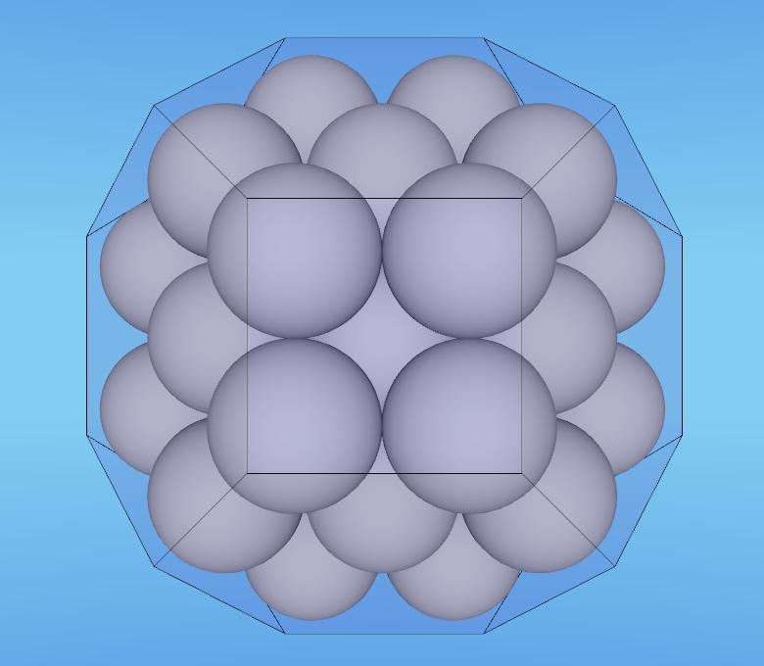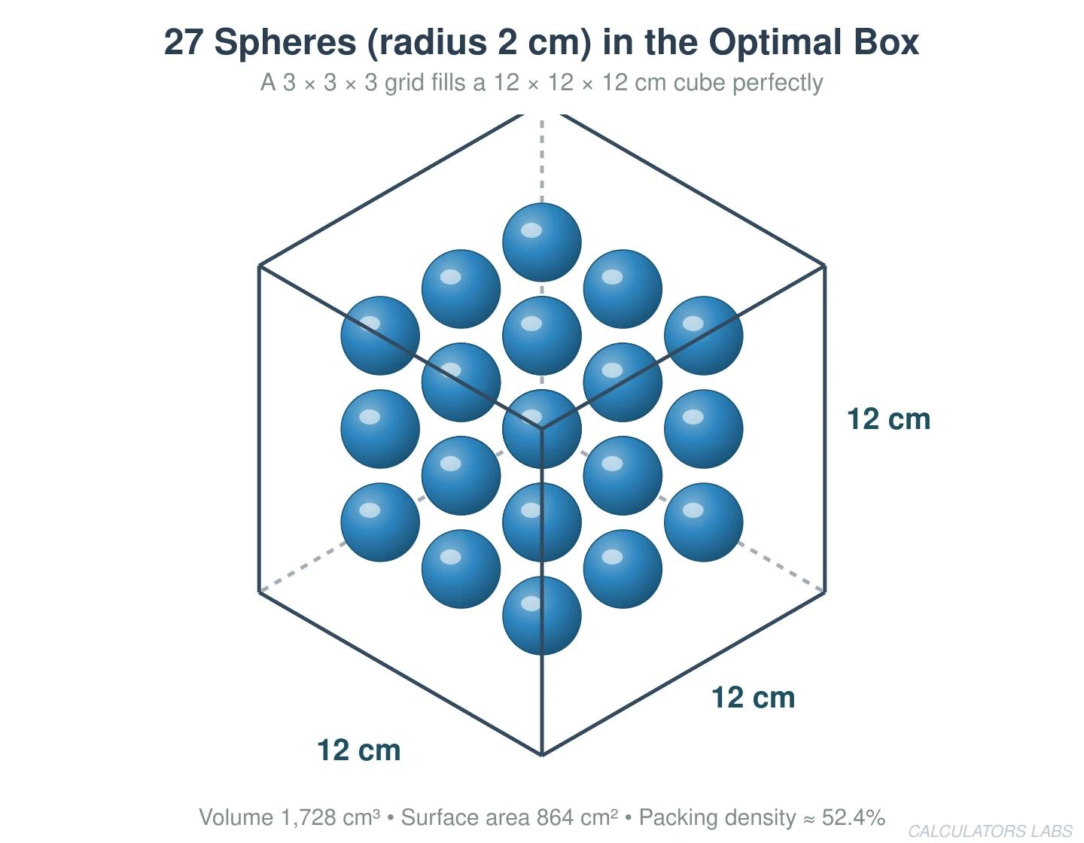
Created by combining multiple spherical components or spherical sections.
Examples:
- Solid formed by joining identical spheres.
- Linear arrangement of identical spheres.
- Stacked spherical arrangement.
- Cubic arrangement of identical spheres.
- Symmetrical spherical cluster.
- Solid formed by joining identical hemispheres.

Hemisphere-Based Repeated Composite Solids
# Source: AI Source: Provided by: [Data Path: Persons Table -> ID Column: 1, Name_En Column: Motasem Essam] -> From: [ChatGPT] on [7/25/2026]
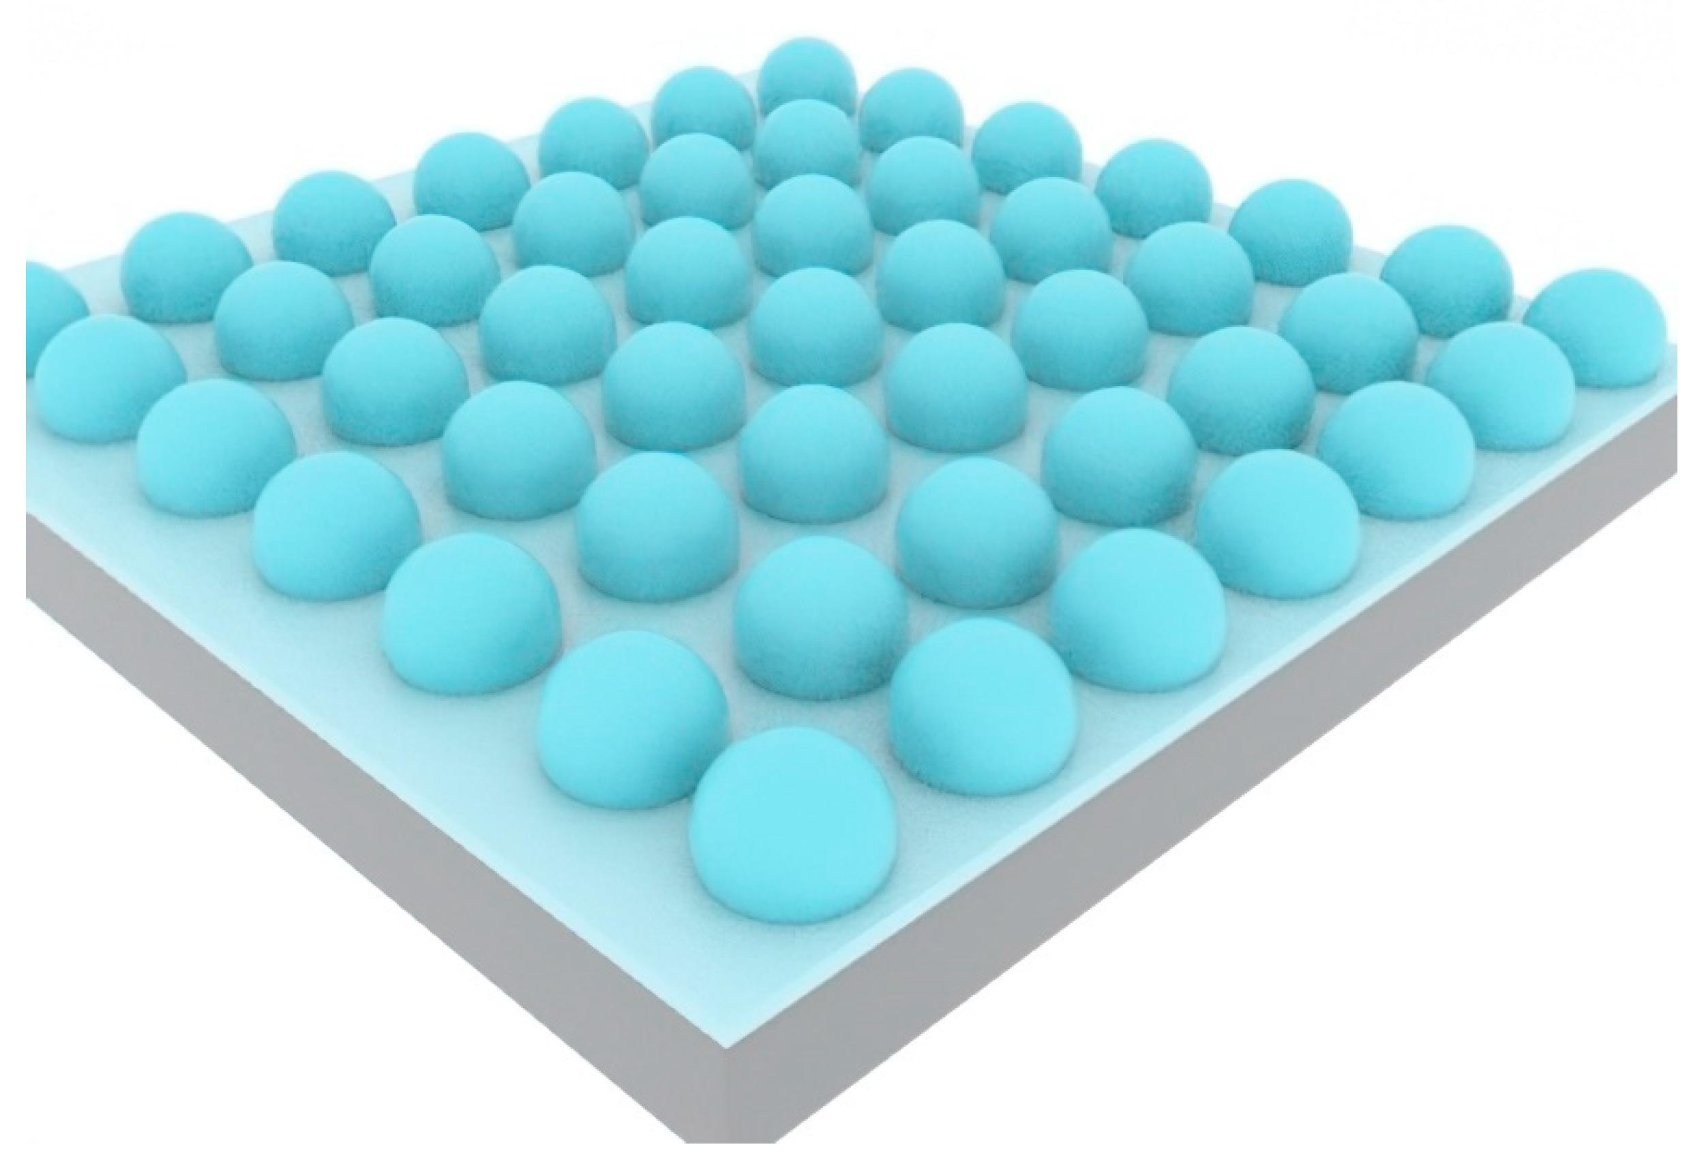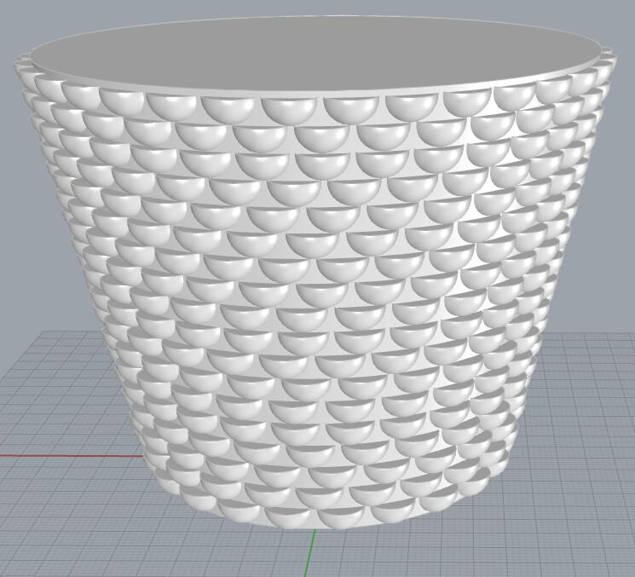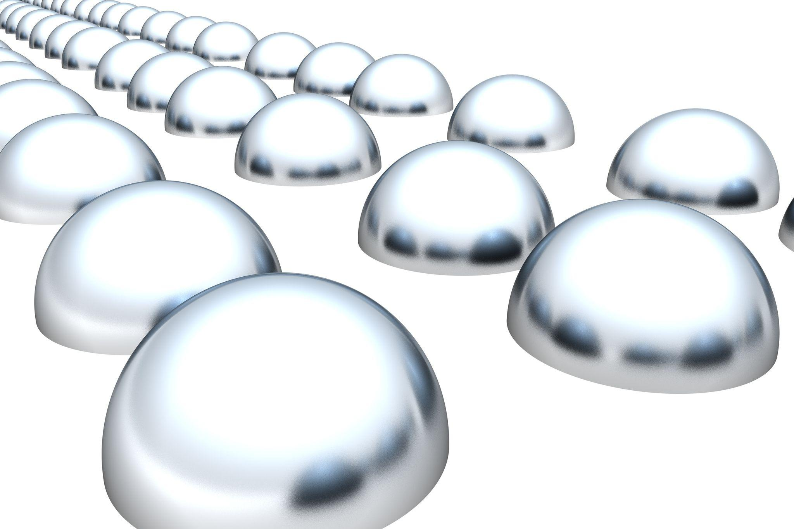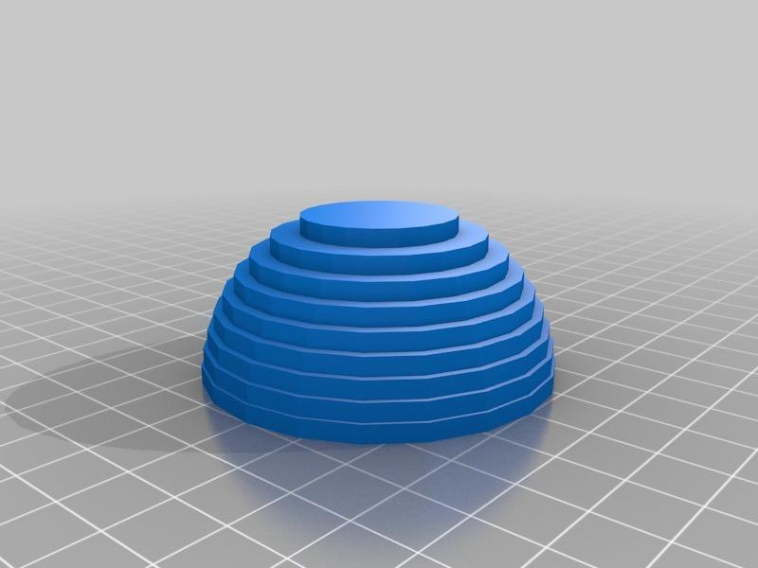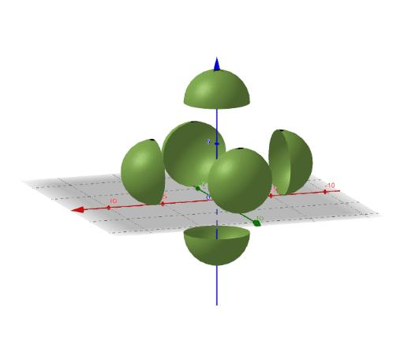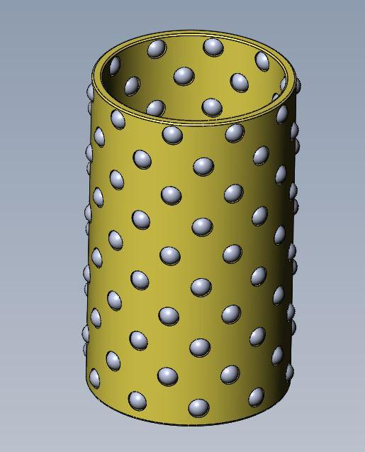
Created by combining multiple hemispherical components.
Examples:
- Structure formed by joining identical hemispheres.
- Repeated hemispherical domes arranged in rows.
- Multiple hemispheres attached to a rectangular prism.
- Symmetrical arrangement of hemispheres.
- Composite structure formed by stacking hemispherical sections.

Mixed-Shape Repeated Composite Solids
# Source: AI Source: Provided by: [Data Path: Persons Table -> ID Column: 1, Name_En Column: Motasem Essam] -> From: [ChatGPT] on [7/25/2026]
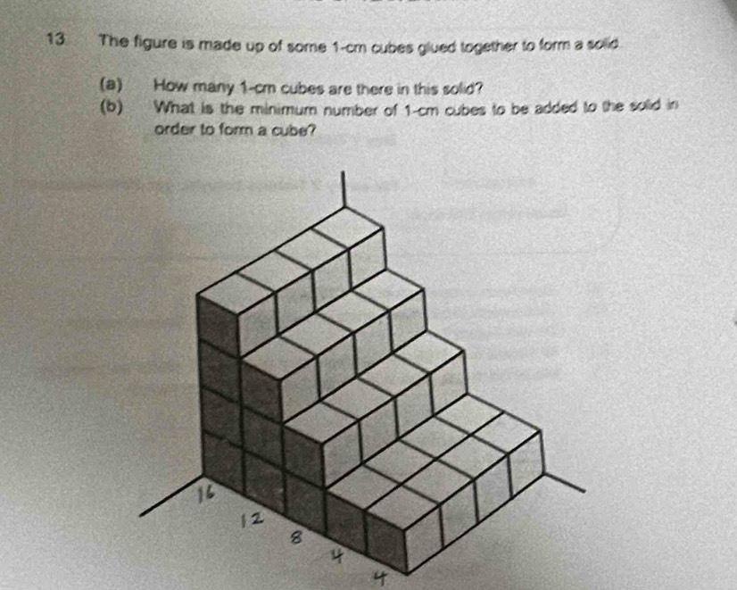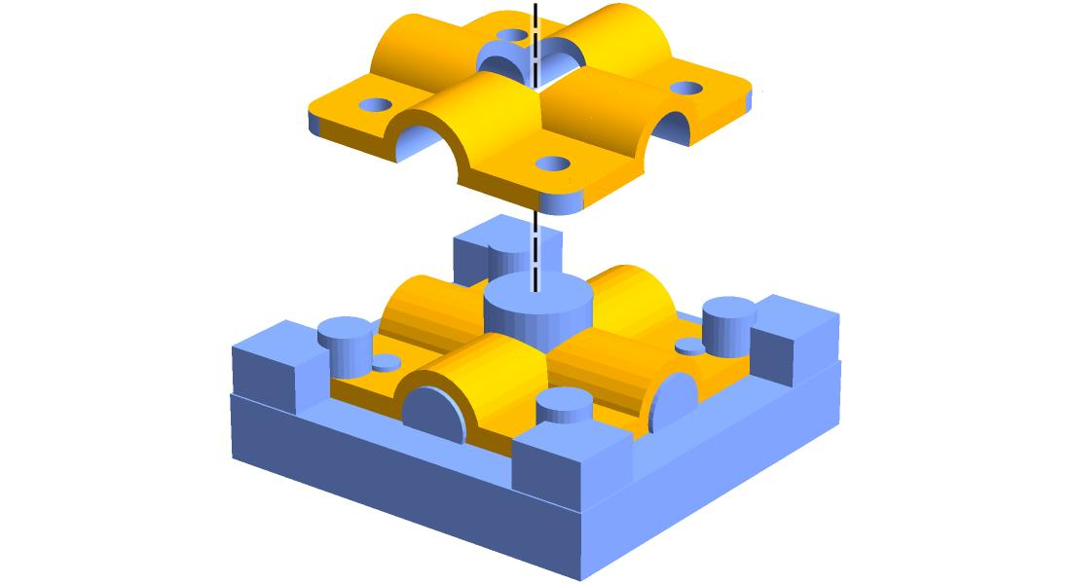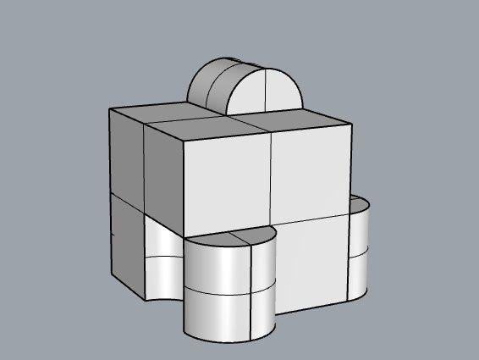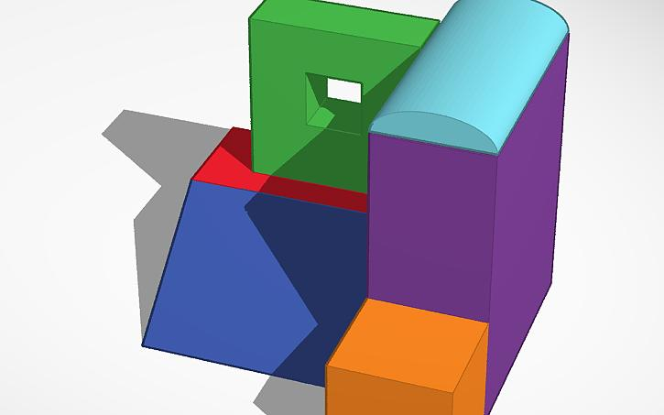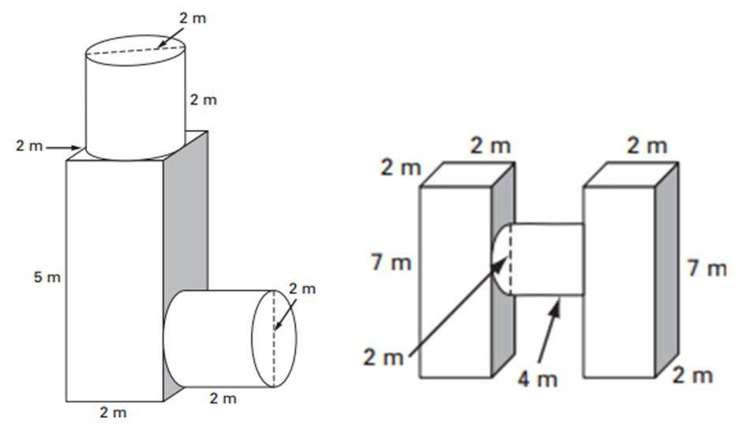
Created by repeating a component pattern containing two or more different geometric shapes.
Examples:
- Repeated combinations of a cube and a cylinder.
- Identical arrangements of rectangular prisms and hemispheres.
- Repeated combinations of cylinders and cones.
- Structure made of identical arrangements of prisms, cylinders, and spheres.
- Multiple identical geometric units joined to form a larger solid.

Classification by Component Arrangement
# Source: AI Source: Provided by: [Data Path: Persons Table -> ID Column: 1, Name_En Column: Motasem Essam] -> From: [ChatGPT] on [7/25/2026]
Composite solids with repeated components can also be classified according to how their components are positioned.
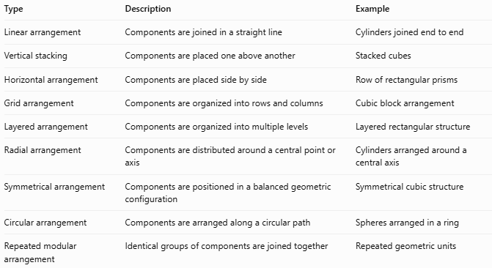
Type | Description | Example
Linear arrangement | Components are joined in a straight line | Cylinders joined end to end
Vertical stacking | Components are placed one above another | Stacked cubes
Horizontal arrangement | Components are placed side by side | Row of rectangular prisms
Grid arrangement | Components are organized into rows and columns | Cubic block arrangement
Layered arrangement | Components are organized into multiple levels | Layered rectangular structure
Radial arrangement | Components are distributed around a central point or axis | Cylinders arranged around a central axis
Symmetrical arrangement | Components are positioned in a balanced geometric configuration | Symmetrical cubic structure
Circular arrangement | Components are arranged along a circular path | Spheres arranged in a ring
Repeated modular arrangement | Identical groups of components are joined together | Repeated geometric units

Classification by Component Dimensions
# Source: AI Source: Provided by: [Data Path: Persons Table -> ID Column: 1, Name_En Column: Motasem Essam] -> From: [ChatGPT] on [7/25/2026]
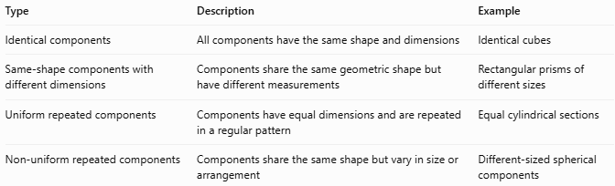
Type | Description | Example
Identical components | All components have the same shape and dimensions | Identical cubes
Same-shape components with different dimensions | Components share the same geometric shape but have different measurements | Rectangular prisms of different sizes
Uniform repeated components | Components have equal dimensions and are repeated in a regular pattern | Equal cylindrical sections
Non-uniform repeated components | Components share the same shape but vary in size or arrangement | Different-sized spherical components

Mathematical Properties and Formulas

Total Volume
# Source: AI Source: Provided by: [Data Path: Persons Table -> ID Column: 1, Name_En Column: Motasem Essam] -> From: [ChatGPT] on [7/25/2026]
For repeated components with identical volumes and no overlapping interiors:
$$\boxed{V_{total}={nV}_{component}}$$
Where:
- $V_{total}$: Total volume of the composite solid.
- $V_{component}$: Volume of one component.
- $n$: Number of repeated components.
For components with different dimensions:
$$\boxed{V_{total}=\sum_{i=1}^{n}{V_{i}}}$$
Important: If components overlap, their intersection volumes must not be counted more than once.

Volume of Common Repeated Components
# Source: AI Source: Provided by: [Data Path: Persons Table -> ID Column: 1, Name_En Column: Motasem Essam] -> From: [ChatGPT] on [7/25/2026]
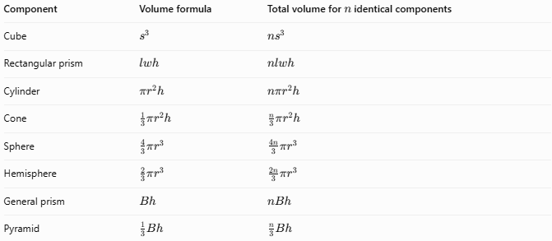
Component | Volume formula | Total volume for $n$ identical components
Cube | $$s^{3}$$ | $${ns}^{3}$$
Rectangular prism | $$lwh$$ | $$nlwh$$
Cylinder | $$πr^{2}h$$ | $$nπr^{2}h$$
Cone | $$\frac{1}{3}πr^{2}h$$ | $$\frac{n}{3}πr^{2}h$$
Sphere | $$\frac{4}{3}πr^{3}$$ | $$\frac{4n}{3}πr^{3}$$
Hemisphere | $$\frac{2}{3}πr^{3}$$ | $$\frac{2n}{3}πr^{3}$$
General prism | $$Bh$$ | $$nBh$$
Pyramid | $$\frac{1}{3}Bh$$ | $$\frac{n}{3}Bh$$

External Surface Area
# Source: AI Source: Provided by: [Data Path: Persons Table -> ID Column: 1, Name_En Column: Motasem Essam] -> From: [ChatGPT] on [7/25/2026]
The external surface area is the total area of all exposed surfaces of the repeated components.
For $n$ identical components:
$$\boxed{{SA}_{total}={nSA}_{component}-2A_{contact,total}}$$
Where:
- ${SA}_{component}$: External surface area of one separate component.
- $A_{contact,total}$: Sum of the areas of all contact interfaces between pairs of components.
- $n$: Number of components.
This formula assumes components are joined along flat contact surfaces without overlapping interiors or additional exposed connecting surfaces.
Important: Contact surfaces become internal when components are joined and must be excluded from the external surface area.

Worked Examples

Example 1: Composite Solid Formed by Stacking Identical Cubes
# Source: AI Source: Provided by: [Data Path: Persons Table -> ID Column: 1, Name_En Column: Motasem Essam] -> From: [ChatGPT] on [7/25/2026]
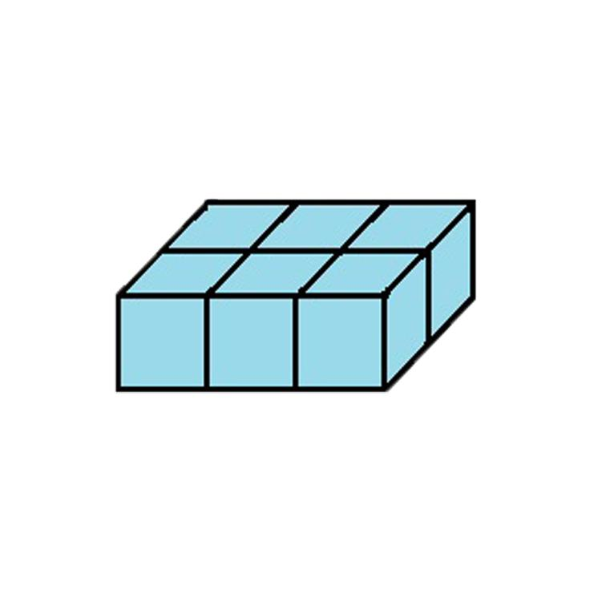
A composite solid is formed by joining 6 identical cubes in a rectangular arrangement.
Given:
- Number of cubes: $n=6$
- Cube side length: $s=4 cm$
Step 1: Calculate the volume of one cube
$$V_{1}=s^{3}$$
$$V_{1}=4^{3}=64{ cm}^{3}$$
Step 2: Calculate the total volume
$$V_{total}={nV}_{1}$$
$$V_{total}=6(64)$$
$$\boxed{V_{total}=384{ cm}^{3}}$$
Step 3: Calculate the external surface area
The cubes form a rectangular prism with dimensions:
- Length: $12 cm$
- Width: $8 cm$
- Height: $4 cm$
$$SA=2(lw+lh+wh)$$
$$SA=2(12(8)+12(4)+8(4))$$
$$\boxed{SA=352{ cm}^{2}}$$

Example 2: Composite Solid Formed by Stacking Identical Cylinders
# Source: AI Source: Provided by: [Data Path: Persons Table -> ID Column: 1, Name_En Column: Motasem Essam] -> From: [ChatGPT] on [7/25/2026]
A composite solid consists of three identical cylinders stacked vertically.
Given:
- Number of cylinders: $n=3$
- Radius: $r=2 cm$
- Height of each cylinder: $h=5 cm$
Step 1: Calculate the volume of one cylinder
$$V_{1}=πr^{2}h$$
$$V_{1}=π(2)^{2}(5)=20π$$
Step 2: Calculate the total volume
$$V_{total}=3(20π)$$
$$\boxed{V_{total}=60π≈188.50{ cm}^{3}}$$
Step 3: Calculate the external surface area
The resulting solid is equivalent to one cylinder with height:
$$H=3(5)=15 cm$$
Its exposed surface area is:
$$SA=2πr^{2}+2πrH$$
$$SA=2π(2)^{2}+2π(2)(15)$$
$$\boxed{SA=68π≈213.63{ cm}^{2}}$$

Important Characteristics
# Source: AI Source: Provided by: [Data Path: Persons Table -> ID Column: 1, Name_En Column: Motasem Essam] -> From: [ChatGPT] on [7/25/2026]
- Formed by combining multiple copies of the same geometric component or component pattern.
- Components may have identical or different dimensions.
- Components may be arranged linearly, vertically, horizontally, radially, or symmetrically.
- Repeated components may form regular or irregular composite structures.
- Contact surfaces become internal when components are joined.
- The total volume is calculated by adding the volumes of the individual components, accounting for overlaps.
- External surface area depends on the exposed surfaces after joining.
- The resulting solid may have a simple or complex geometric boundary.

Comparison with Other Types of Composite Solids
# Source: AI Source: Provided by: [Data Path: Persons Table -> ID Column: 1, Name_En Column: Motasem Essam] -> From: [ChatGPT] on [7/25/2026]
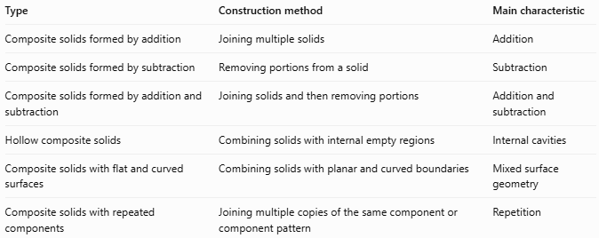
Type | Construction method | Main characteristic
Composite solids formed by addition | Joining multiple solids | Addition
Composite solids formed by subtraction | Removing portions from a solid | Subtraction
Composite solids formed by addition and subtraction | Joining solids and then removing portions | Addition and subtraction
Hollow composite solids | Combining solids with internal empty regions | Internal cavities
Composite solids with flat and curved surfaces | Combining solids with planar and curved boundaries | Mixed surface geometry
Composite solids with repeated components | Joining multiple copies of the same component or component pattern | Repetition

Applications
# Source: AI Source: Provided by: [Data Path: Persons Table -> ID Column: 1, Name_En Column: Motasem Essam] -> From: [ChatGPT] on [7/25/2026]
- Architecture: Designing structures using repeated columns, blocks, domes, and other geometric components.
- Construction: Building walls, layered structures, and foundations using repeated construction units.
- Mechanical engineering: Designing assemblies containing repeated cylindrical or other geometric components.
- Manufacturing: Producing products from repeated geometric sections or identical components.
- Product design: Creating modular products using repeated geometric units.
- Computer-aided design (CAD): Creating complex 3D models through component duplication and geometric patterns.
- Mathematics: Studying spatial arrangements, geometric patterns, volume, and surface area.

Key Points
# Source: AI Source: Provided by: [Data Path: Persons Table -> ID Column: 1, Name_En Column: Motasem Essam] -> From: [ChatGPT] on [7/25/2026]
- Composite solids with repeated components are formed by joining multiple copies of the same geometric component or component pattern.
- Repeated components may have identical or different dimensions.
- Common components include cubes, rectangular prisms, cylinders, cones, spheres, and hemispheres.
- Components can be arranged in linear, stacked, grid, circular, radial, or symmetrical patterns.
- Total volume is calculated by adding the volumes of the components.
- External surface area includes only exposed surfaces.
- Internal contact surfaces must be excluded from external surface area calculations.

Conclusion
# Source: AI Source: Provided by: [Data Path: Persons Table -> ID Column: 1, Name_En Column: Motasem Essam] -> From: [ChatGPT] on [7/25/2026]
Composite solids with repeated components are three-dimensional geometric objects formed by combining multiple copies of the same geometric shape or component pattern. Their components can be arranged in different spatial configurations, including linear, stacked, layered, grid-based, and symmetrical arrangements. Understanding their repeated structures and geometric properties makes it possible to calculate their total volume and external surface area and analyze more complex three-dimensional objects.

